**Automatic Logoff and UserProfile Deletion**

Below document is to setup userprofile deletion if user logoff on his own or automatic logoff happen of user session.

1. Server will generate event ID 4647 in “Security” Log whenever user logoff from server
2. We will create PS script to extract the account name of the user who logged off from server using event ID 4647 and delete his profile using wmi, below is the script  
     
   Dellogs(String) – it will record the log every time task run and delete the user profile

DelUser – it is the main script.

Function dellogs($entry)

{

Add-Content -Path "C:\deluser\dellogs.txt" -Value "$(Get-Date) : $entry"

}

Function DelUser()

{

$srchevnt = @{"LogName"="Security";Id=4647}

$evnt = Get-WinEvent -FilterHashtable $srchevnt -MaxEvents 1

$userdel = $evnt.properties[1].value

Get-WmiObject -Class Win32_userprofile | Where-Object {$_.LocalPath.split("\")[-1] -eq $userdel}|Remove-WmiObject

dellogs("$userdel has been deleted")

}

DelUser

1. 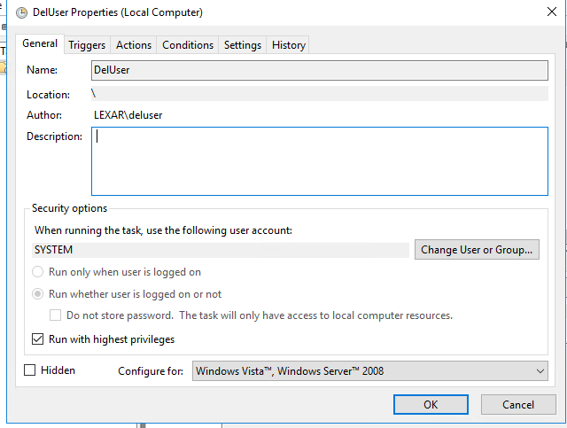Now we need to schedule this task in task scheduler , which will run every time ID 4647 logged into server.

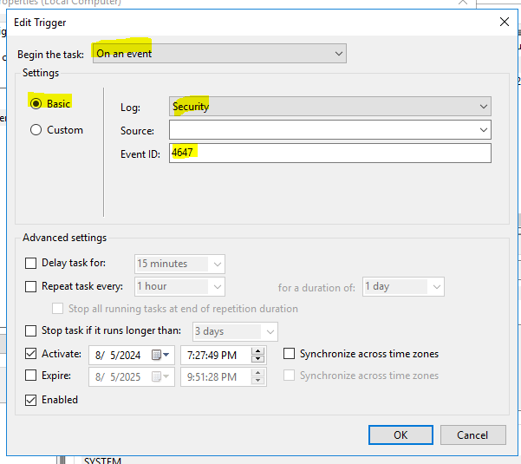

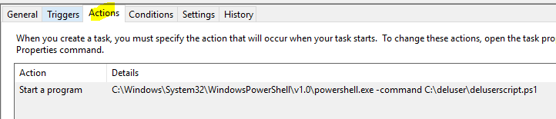

1. 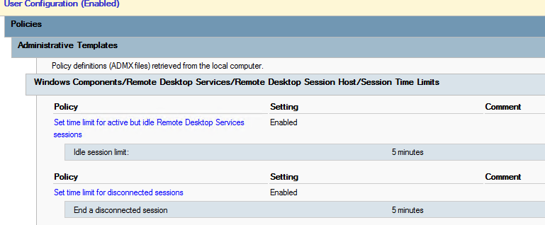Edit the GPO to make idle user session , first disconnect then logoff and add the GPO on users OU.

**Testing**  
  
When user logoff from server on his own.  
  
Before -

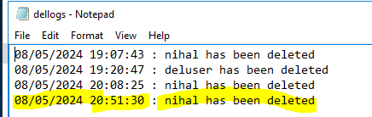  
  
After -  
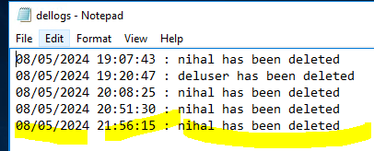

When user leave his session and it got logoff using GPO automatically.

Before –



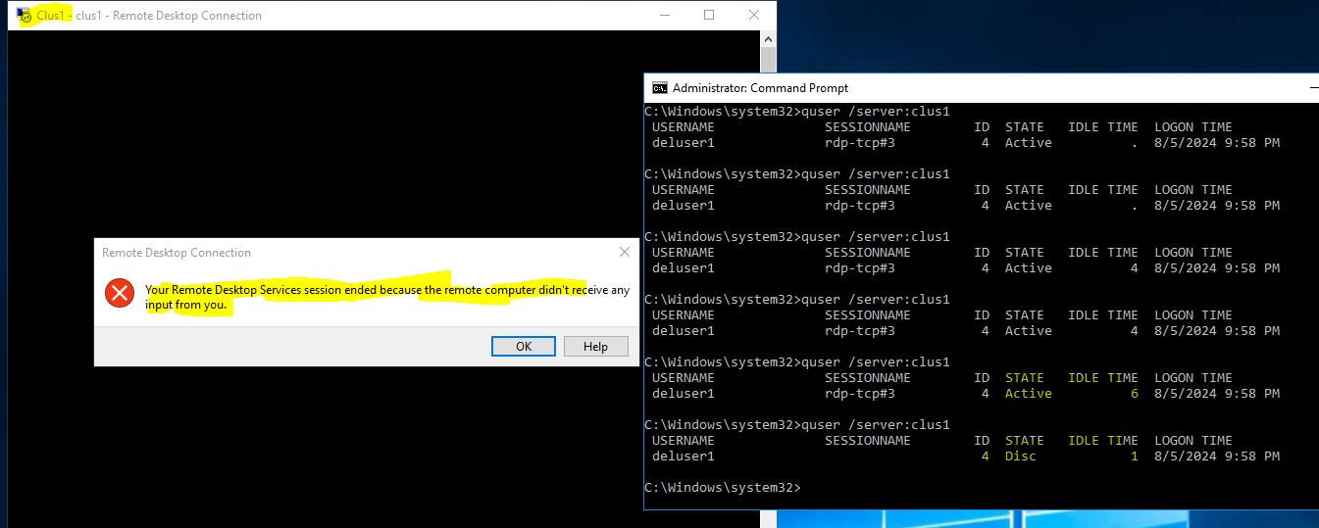After -   
  
It went from active and idle to Disconnect and disconnect to logoff as per GPO and deleted the user profile as per script in task scheduler.

